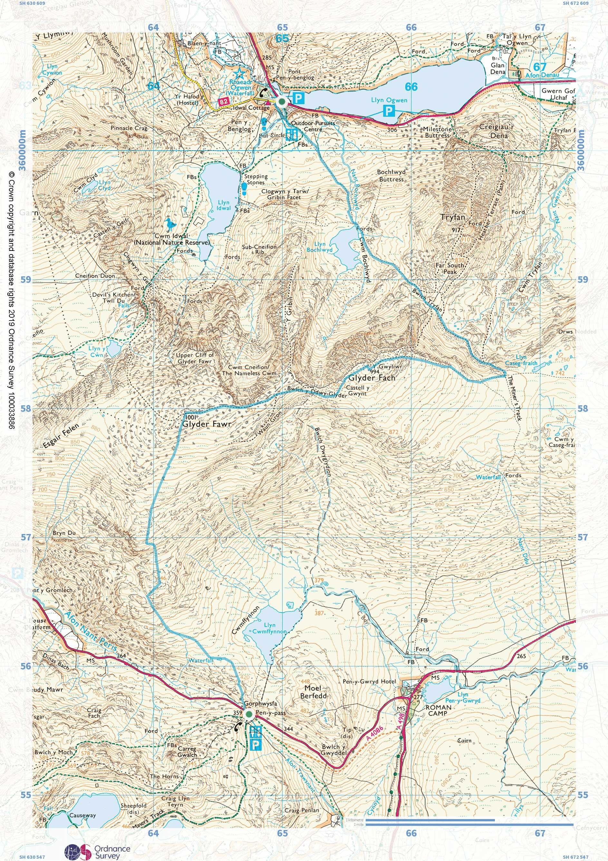
Cambrian Way Maps - Stage 20 - Pen y Pass to Llyn Ogwen (Idwal Cottage)

Part 1 of 1

